1. **Write a blog on Difference between HTTP1.1 vs HTTP2**

**Note : TCP is Transmission Control Protocol (TCP)**

**http1.1**

1) it works on the text format, it compress data by self

2) creating separate TCP connection for every request to make parallel and response multiplexing

3) there is head of line blocking that blocks all request backside it until it until that is doesn`t get its all resource

4 that is user request resource inline for use in multiple pages

5.Header compression : Each HTTP carries a set of Heaters that describe the Transfer resource properties metadata anywhere from 500-800 bytes of over head per transfer and sometimes more HTTP cookies are being used.

**http2**

1. it work on the binary protocol , the client and server both http 2 communicating each other.

2) And another one , request and response multiplexing , this is no need of creating multiple TCP connection, multiple frames of data

3) it uses HPACK for the data compression (work).

4) most plus point of it allows multiplexing so only one TCP connection was required for multiple request at the time .

5) it uses for PUSH frame by server was collects all multiple pages

6) Server push , it this receive multiple response for the single client request

7) compressed request and response header metadata using HPACK powerful technique

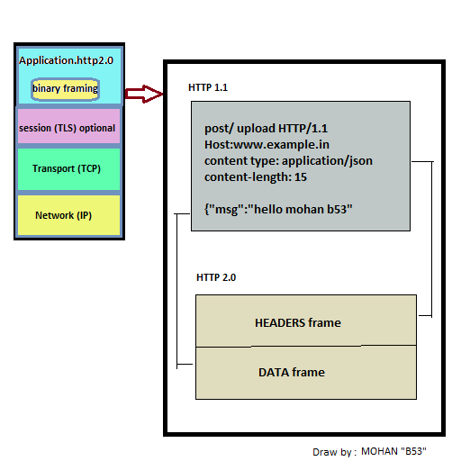

2. Write a blog about objects and its internal representation in Javascript

Object and Its representation :

Object data type was most important topic in javascript . and biggest data type also.

Which mean this data type was better than primitive data type. Its block level of elements.

Primitive data type : (number, string , Boolean…..etc)

Primitive data type was store one value by one variable

Example: var mohanAge = “23”

But object is different ,

Because object can store multiple values by key value

Syntax:

Let objModel = {

Key : value;

Key : value ;

}

**Object variable can store multiple values by key value**

Add value by the property : syntax :

**objectName.objectProperty= propertyValue**

delete a property from the object : Syntax :

**delete ObjectName.objectProperty**

access a property from the Object : syntax :

**objectName.property**

**//or**

**objectName["property”]**

**//or**

**objectName[expression]**

object with object literal

**let student1={name:”mohan”, age: 23, work:”mern developer”}**

Object javascript keyword new

**var person = new Object();**

**person.firstName = “Rishi”;**

**person.lastName = “Mohan”;**

**person.age = 23;**

**person.work = “MERN”;**

submitted by

Mohan suntharam.r **(B53)**

[romanrishi8@gmai.com](mailto:romanrishi8@gmai.com)